Annex L: List of Framework Partnership Agreements
(FPAs) with Civil Society Organisations
African Women’s Development and Communication Network (FEMNET)  Who?  The African Women’s Development and Communication Network is a regional network that gathers over 500 women’s rights organizations. FEMNET was set up in 1988 to share information, experiences, ideas and strategies among African women’s NGOs as a strategy for strengthening women’s capacity to participate effectively the development of the African continent. | 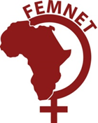
Articulación Feminista MARCOSUR (AFM)  Who?  Articulación Feminista Marcosur is feminist movement based in 10 countries in Latin America. The network represents 13 women and feminists' organisations from Latin America. Its main focus is to promote the development of a feminist political space at national and global levels. | 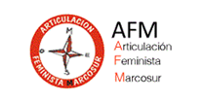
Asian Forum for human rights and development
(AFHRD)
Who?
FORUM-ASIA was founded in 1991 with the mission to promote and protect all human rights, including the right to development, through collaboration and cooperation among human rights organizations and defenders in Asia. It is a membership-based NGO and has the Special Consultative Status with the UN Economic and Social Council (ECOSOC).
Asia Pacific Research Network
(APRN)
Who?
APRN is a regional network, established in 2000 to develop cooperation among alternative research centres of non-governmental organisations (NGO) working on development issues in the Asia Pacific region. APRN seeks to empower communities and peoples’ movements to face globalisation and claim their rights through research and advocacy. The network counts 53 members in 19 countries.
Asian Partnership for the Development of Human Resources in rural Asia
(APDHRA)
Who?
AsiaDHRRA traces its earliest roots to the 1974 Development of Human Resources in Rural Asia Workshop (DHRRAW) and is based in Manila since 2002. This regional partnership is now composed of 11 social development networks and organizations in 11 Asian nations that envision Asian rural communities that are just, free, prosperous, living in peace and working in solidarity towards self-reliance.
Coopération Internationale pour Le Développement et la Solidarité Internationale  (CIDSE)  Who?  CIDSE is an international alliance of 17 faith-based development non-governmental organisations from Europe and North America. CIDSE undertakes joint advocacy in the areas of resources for development, climate justice, food and sustainable agriculture, business and human right, an enabling environment for civil society. It also challenges assumptions on growth, development and consumption. | 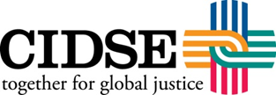
Environnement et Développement du Tiers Monde
(ENDA)
Who?
The network of national associations ENDA gathers 24 members, mainly from Africa, but also from Latin America, South Asia and Europe. The organisation is committed to promoting a more just and equitable, plural and inclusive society, through political, economic and social change. ENDA member organisations work from community-based level to global negotiations.
European NGO Confederation for Relief and Development (CONCORD)  Who?  CONCORD is an umbrella organisation that comprises national NGO platforms from 28 EU Member States, 18 major NGO networks and 2 associate members, including 1800 NGOs. The network covers a wide range of areas of development (such as, inter alia, climate change, migrations, aid effectiveness and gender. | 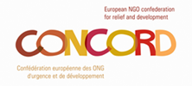
European Network of Political Foundations (ENOP)
Who?
The European Network of Political Foundations, created in 2006, aims at strengthening political foundations and civil society actors in the fields of democracy support and development cooperation. The network is the voice of more than 60 member foundations from more than 23 countries.
European Network on Debt and Development (Eurodad)
Who?
Created in 1990, Eurodad is a network of 46 non-governmental organisations from 20 European countries working on debt cancellation, effective aid, the private turn of aid, and tax justice. The main institutions targeted by the Eurodad network are European governments, the World Bank, the International Monetary Fund and the Organisation for Economic Co-operation and Development.
Fairtrade Labelling Organisation International (FLO)
Who?
Fairtrade International is a global umbrella organisation established in 1997. It unites National Fairtrade organisations and Producer Networks representing over 1.5 million farmers and small producers in 74 countries. Fairtrade International seeks to promote fairer trading conditions and to empower producers to combat poverty. It is tasked with harmonising worldwide Fairtrade standards and certification, and providing technical expertise.
Fédération Ouest Africaine des Associations de Personnes Handicapées (FOAPH)  Who?  FOAPH has as an overall objective to increase the individual and group response capacity of Disabled People’s Organisation, their representativeness, their participation, their influence on national and local public policies and also on the strategies of development stakeholders in the areas of the promotion and implementation of disability rights. Established in 1981, this regional network brings together 16 national federations of associations of persons with disabilities. | 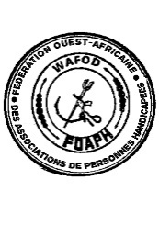
Global Network of Civil Society Organisations for Disaster Reduction (GNDR)  Who?  GNDR was established in 2007 to help reduce disaster risk and support the transition to a safer, more resilient sustainable society. Network members include over 850 civil society organisations and associations, primarily national and local development practitioners working at the community and sub-national levels in 137 countries across every geographical region of the world. | 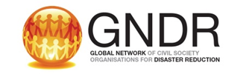
International Cooperative Alliance (ICA)  Who?  The ICA is an independent, non-governmental organisation established in 1895 to unite, represent and serve co-operatives worldwide. The Alliance has 286 national members in 94 countries. The movement represented by the Alliance counts more than one billion members across the Planet, working for 2.5 million cooperative enterprises that cover all sectors. | 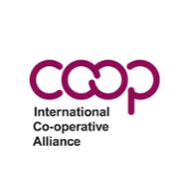
International Federation for Human Rights  Who?  FIDH is an international human rights NGO federating 178 organizations from 120 countries. Since 1922, FIDH has been defending all civil, political, economic, social and cultural rights as set out in the Universal Declaration of Human Rights. It acts at national, regional and international levels in support of its member and partner organisations to address human rights abuses and consolidate democratic processes. | 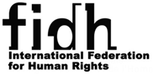
Forus  Who?  Forus brings together 62 national platforms worldwide and 6 regional coalitions (22,000 organizations in total). Founded in 2008, this network's values are: the protection of human rights, inclusion of the most vulnerable populations, fight against inequalities and injustice, eradication of poverty and sustainable development. | 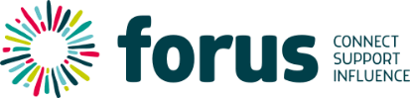
La Via Campesina (LVC)  Who?  LVC is an international social movement of small holder farmers and rural workers, that defends small-scale sustainable agriculture to promote social and economic justice, cool the Planet and defend a dignified life for rural people. LVC comprises about 163 local and national organisations in 73 countries from Africa, Asia, Europe, North America and Latin America. | 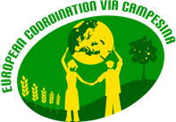
Rede Jubileu Sul America  Who?  Jubilee South is a broad-based, pluralistic network of popular organizations, social movements, religious groups and debt campaigns over 50 countries of Africa, Asia and the Pacific, and Latin America and the Caribbean. Jubilee South Americas is a member of the organisation and the regional representation covering 20 countries of Latin America and the Caribbean through 24 affiliated organisations. Its special contribution is to give voice, leadership, and strength to South peoples in the struggle against debt domination. | 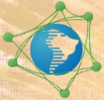
Red Latinoamericana por la defensa de los derechos de los niño, niñas y adolescentes (REDLAMYC)  Who?  Founded in 2000, REDLAMYC is a network that covers 18 countries of Latin America and the Caribbean through 24 member organisations. Its objective is to promote the rights of children and adolescents in Latin America and the Caribbean. | 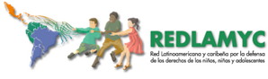
Solidar
Who?
SOLIDAR is a European network of 60 NGOs based in 27 countries (22 of which are EU countries). This platform works to advance social justice in Europe and worldwide by voicing the concerns of its member organisations to the European and international institutions across the policy sectors social affairs, international cooperation and education.
Transparency International  Who?  Established in 1993, Transparency International is a global movement present in more than 100 countries, whose mission is to stop corruption and to promote transparency, accountability and integrity at all levels and across all sectors of society, including government, politics, business and civil society. | 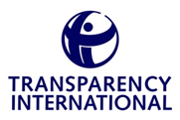
Women Engage for a Common Future International (WECF International)  Who?  WECF International is a non-governmental organization established in 1994 following the 1992 Earth Summit in Rio de Janeiro, to give women a stronger voice in the field of sustainable development and environment. The network comprises more than 150 women’s and environmental organizations in 50 countries. | 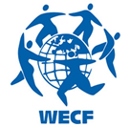
World Alliance for Citizen Participation (CIVICUS)  Who?  CIVICUS is a global alliance of civil society organisations, founded in 1993, with members in over 150 countries. CIVICUS works to strengthen citizen action and civil society throughout the world, especially in areas where participatory democracy and citizens’ freedom of association are threatened. | 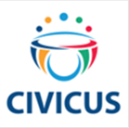
International Trade Union Confederation (ITUC)  Who?  ITUC is the world's largest trade union federation, founded in 2006, representing 176 million workers in 162 countries. The ITUC's primary mission is the promotion and defence of workers' rights and interests, through international cooperation between trade unions, global campaigning and advocacy within the major global institutions. | 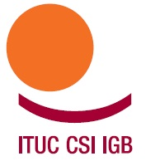
International Organisation of Employers (IOE)  Who?  The IOE is a unique international structure of representations of employers' organisations with 150 national employers' organisation members in 143 countries. Founded in 1920, IOE has been supporting and representing the worldwide business community in international labour and social policy forums across the multilateral system, and in other high-level forums such as the G20, with the aim of ensuring that such policy promotes the viability of business. | 